**Off-Platform Project: Boss Machine**

**In this project, you will create an entire API to serve information to a Boss Machine, a unique management application for today’s most accomplished (evil) entrepreneurs.**

**Boss Machine**

**Project Overview**

In this project, you will create an entire API to serve information to a Boss Machine, a unique management application for today’s most accomplished (evil) entrepreneurs. You will create routes to manage your ‘minions’, your brilliant ‘million dollar ideas’, and to handle all the annoying meetings that keep getting added to your busy schedule.

You can view a video demonstration of the final app here:

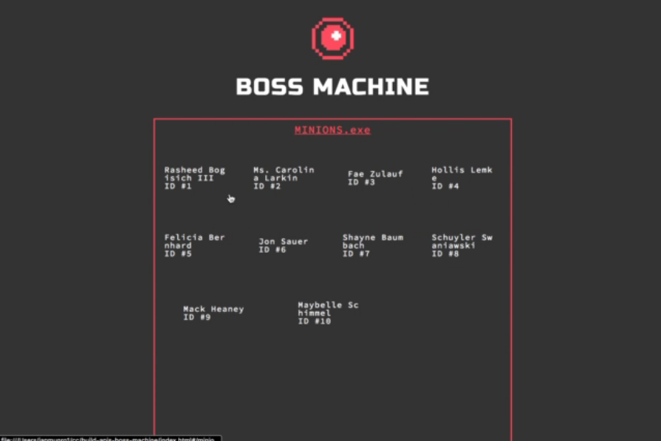

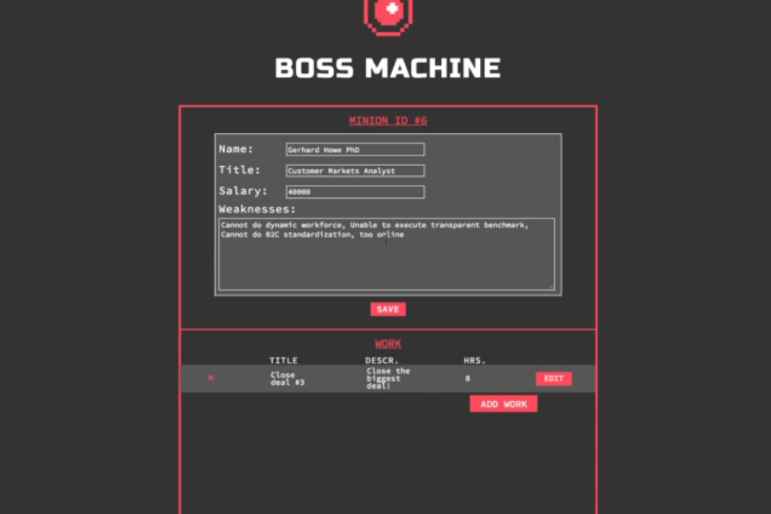

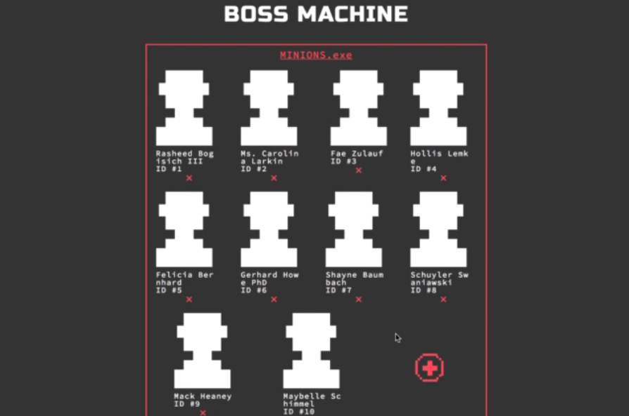

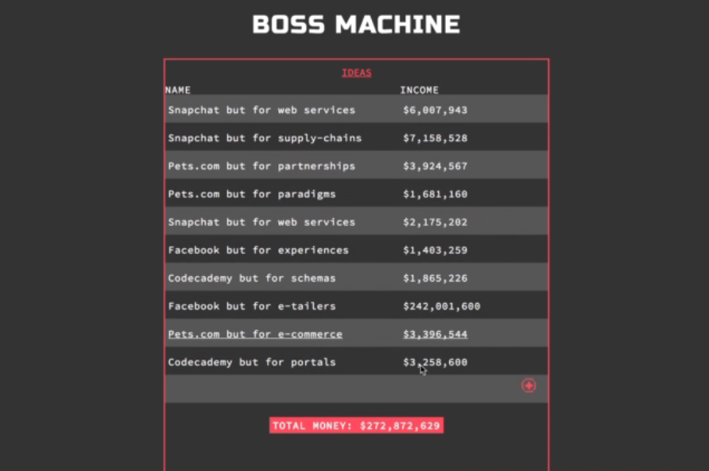

**How to Begin**

To start, download the starting code for this project [here](https://content.codecademy.com/PRO/skill-paths/backend-javascript/projects/boss-machine/project-4-boss-machine-start.zip). After downloading the zip folder, double click it to uncompress it and access the contents.

Once you have the project downloaded, you’ll need to run some terminal commands to get the application started. First, open the root project directory in your terminal. Run npm install to install the dependencies of this project and build the front-end application. Once it has finished installing, you can run npm run start to begin your server. You’ll see Server listening on port 4001 in the terminal. The npm run start script will automatically restart your server whenever you make changes to the **server.js** file or **server/** folder. If you want to turn this off, simply start your server with the node server.js command. You can kill either process with the Ctrl + C command.

To see the application in its initial, non-working state, simply open **index.html** in a web browser. You should use [Google Chrome](https://www.google.com/chrome/browser/desktop/index.html) (at least version 60) or [Firefox](https://www.mozilla.org/en-US/firefox/new/) (at least version 55). The links above will let you download the latest release of either browser if you do not have it or are unsure of which version you’re running.